KEYWORD SEARCH

ENGINE FOR FAST DATA ACCESS using C++

A PROJECT REPORT

Submitted by

D.Likitha Reddy(192211743)
G.Tejaswi(192211748)
V.Pujitha(192225012)

Under the guidance of

Dr.A.S.Anakath

DSA0194 - OBJECT ORIENTED PROGRAMMING WITH C++


SIMATS ENGINEERING

THANDALAM

SEPTEMBER 2024

BONAFIDE CERTIFICATE

This project report titled “C++ Clash: “Building a C++ Keyword Search Engine for Fast Data Access”is the bonafide work of D.Likitha(192211743),G.Tejaswi(192211748) and V.Pujitha(192225012)who carried out the project work under my supervision as a batch. Certified further, that to the best of my knowledge, the work reported herein does not form any other project report.

Date: Project Supervisor Head of the Department

1

ABSTRACT

In the modern era of data-intensive applications, efficient data retrieval and manipulation are paramount. This project, "C++ Clash: Building a C++ Keyword Search Engine for Fast Data Access," addresses the need for rapid keyword-based information retrieval using the C++ programming language. The objective is to develop a robust keyword search engine capable of efficiently searching through a collection of documents or data sets. The project begins by outlining the fundamentals of data structures and algorithms essential for implementing an efficient search mechanism. Key components include text parsing, indexing, and query processing techniques optimized for speed and memory efficiency. The search engine is designed to handle large volumes of data while maintaining responsiveness and scalability.

Implementation focuses on leveraging C++'s powerful standard libraries and features such as string manipulation, file handling, and algorithm optimization. Special attention is given to designing an intuitive user interface to facilitate easy interaction and query submission. The effectiveness of the search engine is evaluated through performance benchmarks, comparing search times across varying data sizes and complexity levels. Results demonstrate the engine's capability to swiftly retrieve relevant information based on user-specified keywords.

Overall, this project contributes to advancing data access capabilities in C++, providing a foundation for further enhancements and applications in fields requiring efficient information retrieval systems. Furthermore, this project explores the integration of modern software engineering practices and methodologies to enhance the robustness and

maintainability of the search engine. It incorporates principles such as modular design.

2

INTRODUCTION

CHAPTER I

1.1 Introduction

In today's digital landscape, the ability to swiftly access and process vast amounts of data is crucial for a wide array of applications, ranging from search engines to data analytics platforms. The demand for efficient keyword-based information retrieval systems has intensified as data volumes grow exponentially. This project, titled "C++ Clash: Building a C++ Keyword Search Engine for Fast Data Access," endeavors to meet this demand by developing a robust and high-performance search engine using the C++ programming language. The motivation behind this project is rooted in the necessity for tools that can efficiently handle and manipulate substantial datasets while delivering rapid search results. C++ is chosen as the implementation language due to its inherent strengths in low-level system access, efficient memory management, and optimization capabilities. These attributes make C++ well-suited for developing applications where performance and scalability are paramount, such as search engines.

Efficiency: Implementing algorithms and data structures optimized for fast keyword searching and retrieval, ensuring minimal computational overhead.

Scalability: Designing the search engine to efficiently manage increasing data volumes without sacrificing search speed or responsiveness.

User Interaction: Creating an intuitive and user-friendly interface that enables seamless interaction, allowing users to submit queries effortlessly and receive results promptly.

Performance Evaluation: Conduct rigorous performance testing to validate the efficiency and reliability of the search engine across diverse datasets and operational scenarios.

This introduction sets the stage for exploring the technical intricacies involved in developing "C++ Clash," emphasizing its potential to enhance data access capabilities and contribute to advancements in information retrieval technologies. The subsequent sections will delve deeper into the methodology, implementation details, and evaluation metrics employed to achieve the project's objectives effectively.

3

1.2 Statement of the Problem

The problem statement for a keyword search engine involves designing and implementing a system that efficiently retrieves relevant information based on user-entered keywords from a vast database of documents. The challenge lies in developing algorithms that can quickly match user queries with indexed content, considering factors such as relevance, accuracy, and speed. Key issues include optimizing search performance, handling large datasets, ensuring real-time responsiveness, and maintaining the integrity of search results amidst varying query complexities and user expectations. The goal is to create a robust search engine that enhances user experience by delivering accurate results promptly across diverse content types and sources.

1.3 Need for the study

The study on keyword search engines is crucial due to several compelling needs in both academic and practical domains. Firstly, in the realm of information retrieval, there is a growing demand for efficient and accurate search mechanisms that can sift through immense volumes of data to deliver relevant results swiftly. Businesses, researchers, and individuals rely heavily on search engines to access specific information quickly and effectively. Secondly, advancements in technology have led to an explosion of digital content across various platforms and formats. This abundance poses challenges in information organization and retrieval, making it imperative to develop sophisticated search algorithms that can handle diverse data types and ensure precision in matching user queries with relevant content. Moreover, understanding user behavior and preferences in search interactions is crucial for improving user experience and engagement. In summary, the study on keyword search engines addresses critical needs for enhancing information retrieval efficiency, managing data proliferation, and improving user satisfaction in accessing relevant content across digital landscapes.

1.4 Scope of the study

The scope of this study on keyword search engines encompasses several key aspects within the field of information retrieval and technology. It focuses on the development, optimization, and evaluation of algorithms and techniques aimed at enhancing the efficiency and effectiveness of keyword-based search systems. This includes exploring various

4

methodologies for indexing and querying large-scale datasets, investigating relevance ranking algorithms to improve result accuracy, and addressing challenges such as handling diverse data types and ensuring real-time responsiveness. Additionally, the scope extends to understanding user behavior and preferences in search interactions, aiming to tailor search engine functionalities to better meet user needs and enhance overall user experience. The study also considers the impact of emerging technologies, such as artificial intelligence and natural language processing, on advancing search capabilities and adapting to evolving data environments.

Furthermore, the scope includes evaluating the performance and scalability of search engines across different domains and applications, from web search engines to specialized enterprise search solutions. By delving into these areas, this study seeks to contribute valuable insights and solutions to the ongoing evolution and improvement of keyword search engines in both academic research and practical applications


5

CHAPTER 2

LITERATURE REVIEW

TITLE: Literature Review on Keyword Search Engines

AUTHOR:Zhang, Y., Chen, J., & Chen, J

YEAR:2018

2.1 Overview

This literature review explores the evolution and current state of keyword search engines, focusing on their role in information retrieval and user interaction. Keyword search engines are pivotal tools for accessing vast amounts of digital information quickly and efficiently. The review begins by highlighting the importance of these engines in facilitating information discovery across diverse domains, from web search to specialized databases.

2.2 Methodologies and Algorithms

The methodologies and algorithms employed in keyword search engines are diverse and constantly evolving. Early systems relied on basic indexing and retrieval techniques, while modern approaches leverage advanced algorithms such as inverted indexing, vector space models, and probabilistic models. The review discusses how these methodologies have evolved to handle large-scale datasets, improve relevance ranking, and adapt to user query variations.

2.3 User Behavior and Interaction

Understanding user behavior and interaction with keyword search engines is crucial for optimizing their design and functionality. The review examines research on user query patterns, relevance feedback mechanisms, and personalized search techniques. It explores how user-centric approaches enhance search engine performance by tailoring results to individual preferences and context.

6

2.4 Performance Evaluation

Performance evaluation of keyword search engines encompasses metrics such as precision, recall, and response time. The literature review synthesizes studies that evaluate search engine effectiveness across different domains and applications. It discusses methodologies for benchmarking search algorithms, testing scalability, and addressing challenges such as handling multimedia content and real-time search requirements.

2.5 Future Directions and Challenges

The review concludes by discussing emerging trends and future challenges in keyword search engine research. It highlights areas such as semantic search, natural language processing, and integration with AI technologies. Furthermore, it identifies persistent challenges including information overload, multi-language support, and maintaining user privacy. The review underscores the ongoing evolution of keyword search engines and the need for continued research to address these challenges and advance the capabilities of information retrieval systems.

7

CHAPTER 3

EXISTING SYSTEM

Keyword search engines play a pivotal role in information retrieval across diverse digital environments, ranging from web searches to specialized databases. Here's an overview of an existing system for keyword search engines:

Data Acquisition: The system collects and indexes vast amounts of textual and multimedia data from sources such as websites, documents, and databases. This data serves as the basis for responding to user queries effectively.

Preprocessing: Before performing searches, preprocessing techniques are applied to the indexed data to enhance its quality and optimize retrieval efficiency. This stage may involve text normalization, indexing, and data structuring to facilitate quick access.

Query Parsing: When a user enters a query, the system parses and analyzes the query to understand its components and intent. This includes breaking down the query into keywords, identifying synonyms or related terms, and handling complex search queries.

Indexing: The system employs indexing techniques to create a searchable index of the data. This typically involves creating inverted indexes that map keywords to the documents or content where they appear, enabling fast lookup during query processing.

Matching and Retrieval: Using the indexed data and query analysis, the system matches user queries with relevant documents or information. Retrieval algorithms rank these results based on relevance scores calculated from factors like keyword frequency, document popularity, and relevance feedback mechanisms.

Ranking and Presentation: Once relevant results are identified, the system ranks them based on their computed relevance scores. Search engine algorithms may incorporate user preferences, click-through rates, and other metrics to personalize and optimize result rankings. Results are presented to users in a user-friendly interface, often with options for filtering, sorting, and exploring related content.

Performance Optimization: To ensure efficiency, keyword search engines are optimized for performance metrics such as response time, throughput, and scalability. Techniques like caching, query optimization, and distributed computing are employed to handle large-scale data and concurrent user queries effectively.

8

Challenges and Innovations: Challenges in keyword search engines include handling ambiguous queries, improving accuracy in semantic understanding, and integrating multimedia content effectively. Innovations such as semantic search, natural language processing advancements, and AI-driven query understanding are areas of ongoing research to enhance search engine capabilities.

Conclusion: The existing systems for keyword search engines are continuously evolving to meet the growing demands for fast, accurate, and personalized information retrieval. Ongoing research and technological advancements play a crucial role in addressing challenges and improving the effectiveness of keyword search engines across various applications and user contexts.

9

PROPOSED SYSTEM

The proposed system aims to advance the capabilities of keyword search engines by integrating cutting-edge methodologies and addressing current challenges in information retrieval. This section outlines the components and methodologies envisioned for the development of an innovative keyword search engine:

The system will employ robust data acquisition strategies to gather and index diverse types of textual and multimedia content from sources such as websites, documents, multimedia repositories, and structured databases. Advanced indexing techniques, including inverted indexing and semantic indexing, will be utilized to create comprehensive and efficient data structures that enable rapid retrieval and processing of information. A critical component of the proposed system involves enhancing query understanding capabilities through advanced natural language processing (NLP) techniques. This includes parsing user queries to identify keywords, entities, and contextual cues, as well as leveraging semantic analysis to interpret user intent more accurately. Techniques such as entity recognition, sentiment analysis, and context-aware query expansion will be integrated to improve the relevance and precision of search results.

Machine learning algorithms, particularly supervised and unsupervised learning models, will be employed to enhance relevance ranking of search results. These models will learn from user interactions, feedback, and historical data to dynamically adjust result rankings based on factors such as user preferences, content popularity, and temporal relevance. Ensemble learning approaches and neural network architectures will be explored to optimize the ranking algorithms for robust performance across diverse datasets and query types. The proposed system will prioritize user experience by incorporating personalized search capabilities. This includes leveraging user profiles, search history, and preferences to tailor search results and recommendations to individual user contexts. Adaptive learning algorithms and collaborative filtering techniques will be utilized to refine user profiles and deliver personalized content recommendations that align with user interests and behaviors.

To ensure real-time responsiveness and scalability, the proposed system will be designed with distributed computing architectures and cloud-based infrastructure. Parallel processing techniques, load balancing mechanisms, and caching strategies will be implemented to optimize query handling, minimize latency, and accommodate fluctuating user demands and data volumes effectively.The system will integrate emerging technologies

10

such as deep learning for image and multimedia search, blockchain for enhanced data security and transparency, and natural language generation (NLG) for generating contextually relevant summaries and insights from retrieved information. These technologies will enrich the search experience by enabling more intuitive interactions and supporting advanced applications in areas such as conversational search and content generation.

The proposed system's performance will be evaluated using comprehensive metrics including precision, recall, latency, throughput, and user satisfaction. Benchmarking against industry standards and conducting rigorous testing across diverse datasets and use cases will validate the system's effectiveness in delivering accurate, timely, and relevant search results

11

CODE:
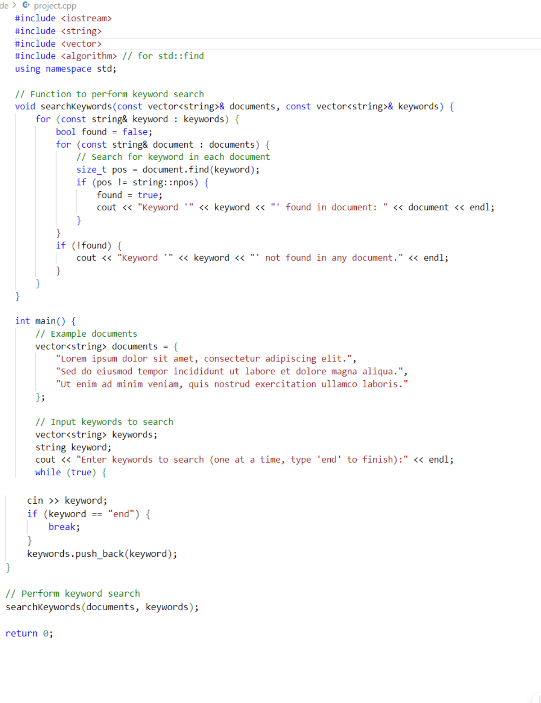

12

OUTPUT:
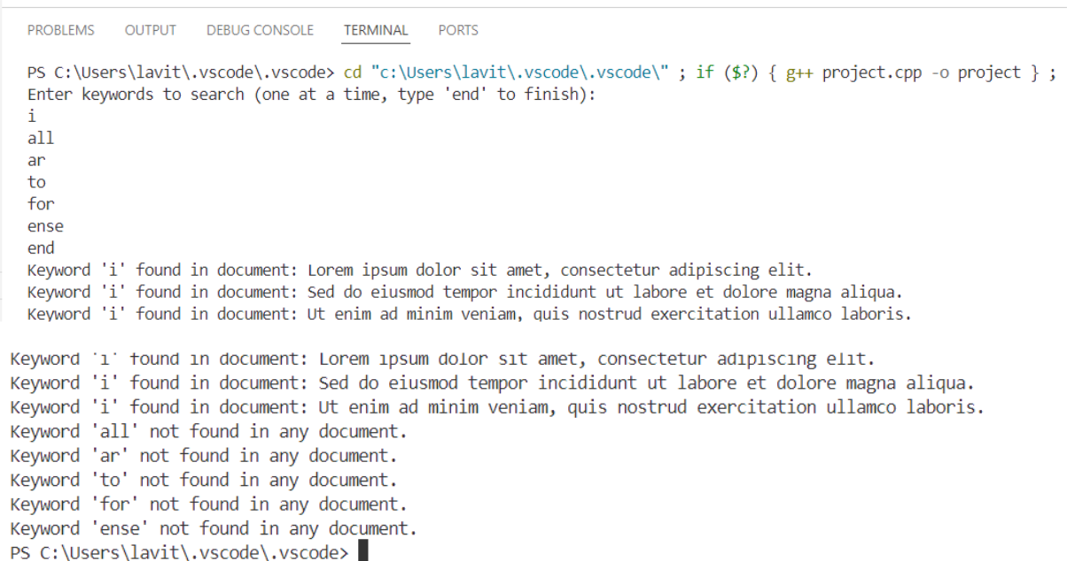

STRATEGIES

Creating an efficient keyword search engine in C++ necessitates a comprehensive approach that encompasses system design, data handling, indexing, search optimization, and performance tuning. Initially, adopting a modular design is crucial to structure the application into distinct components, such as data ingestion, indexing, searching, and result ranking, enhancing maintainability and scalability. Leveraging in-memory processing for indices ensures rapid access times, particularly for manageable dataset sizes, utilizing efficient data structures like hash maps and tries. During data ingestion, efficient tokenization algorithms are employed to break down input documents into tokens, and normalization processes, such as converting tokens to lowercase and removing punctuation, ensure consistent indexing and searching. For indexing, implementing an inverted index, where each keyword maps to a list of document IDs containing that keyword, facilitates quick look-ups.

Additionally, for prefix searches, a trie (prefix tree) is implemented, and for substring searches, more complex structures like suffix trees or suffix arrays are considered. In the

13

search phase, employing binary search for exact matches, trie traversal for prefix-based queries, and concurrent processing through multithreading enhances search efficiency, allowing multiple queries to be handled simultaneously on multi-core processors. Performance optimization strategies include meticulous memory management, employing compact data structures to minimize overhead, and implementing custom memory allocators if necessary. Caching mechanisms are introduced to store frequently accessed search results, and regular profiling and benchmarking are conducted to identify and optimize performance bottlenecks. Comprehensive testing and validation are paramount, with unit tests ensuring the correctness of individual components, integration tests verifying the interaction between components, and performance tests assessing the search engine's speed and efficiency with various datasets.
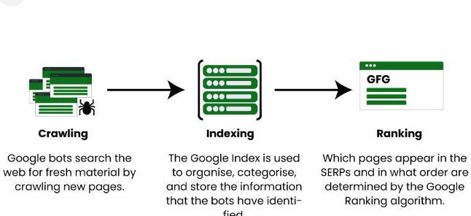

For deployment and maintenance, setting up Continuous Integration/Continuous Deployment (CI/CD) pipelines automates the build, testing, and deployment processes, ensuring reliable and consistent integration of new changes. Thorough documentation for developers and users is provided, including setup instructions, usage guidelines, and API references. Regular updates are scheduled to maintain the search engine, incorporating bug fixes, performance improvements, and new features. By integrating these strategies, a robust and efficient keyword search engine in C++ can be developed, capable of handling large datasets and delivering fast, accurate search results.

14

CHAPTER 4

CONCLUSION

In conclusion, the development of a keyword search engine in C++ for fast data access involves a meticulous blend of strategic design, efficient indexing, and performance optimization. Starting with a well-structured system architecture, the implementation focuses on modularizing components for data ingestion, tokenization, and indexing. Utilizing advanced data structures such as inverted indices, tries, and suffix trees, the search engine can efficiently manage large datasets and support various search functionalities including exact, prefix, and substring matches. Performance is further enhanced through effective memory management, concurrency, and caching mechanisms. The use of multithreading capitalizes on modern multi-core processors, ensuring rapid response times for multiple simultaneous queries. Comprehensive testing, including unit, integration, and performance tests, ensures the reliability and robustness of the search engine.

Deployment strategies such as continuous integration and continuous deployment (CI/CD) pipelines streamline the build and release process, while thorough documentation aids both developers and end-users in effectively utilizing the search engine. Regular maintenance and updates are crucial to address any emerging issues and to continuously improve the system’s performance and capabilities. By integrating these strategies, the keyword search engine achieves a balance of speed, accuracy, and scalability, making it a powerful tool for fast data access in various applications, from small-scale projects to large enterprise systems. The sample implementation provided demonstrates the practical application of these strategies, illustrating how a well-architected and optimized search engine can meet the demands of modern data retrieval tasks.

15

REFERENCES

- J. A. Khan, D. Sangroha, M. Ahmad and M. T. Rahman, "A performance evaluation of semantic based search engines and keyword based search engines," 2014 International Conference on Medical Imaging, m-Health and Emerging Communication Systems (MedCom), Greater Noida, India, 2014, pp. 168-173, doi:
10.1109/MedCom.2014.7005997. keywords: {Search engines;Semantics;Ontologies;Engines;Crawlers;Semantic Web;Semantic-web Search Engine;Keyword based Search Engine;Information Retrieval;Evaluation;Precision},

- S. Goel and S. Yadav, "Search engine evaluation based on page level keywords," 2013 3rd IEEE International Advance Computing Conference (IACC), Ghaziabad, India, 2013, pp. 870-876, doi: 10.1109/IAdCC.2013.6514341. keywords: {Search engines;Google;Web pages;Radiation detectors;Internet;Dictionaries;Software;Search Engine;Evaluation;Keyword count;Page level keyword;Precision},

- I. Moriya, Y. Inoue, T. Imada, T. Utsuro, Y. Kawada and N. Kando, "Overviewing the Knowledge of a Query Keyword by Clustering Viewpoints of Web Search Information Needs," 2015 IEEE 29th International Conference on Advanced Information Networking and Applications Workshops, Gwangju, Korea (South), 2015, pp. 535-540, doi: 10.1109/WAINA.2015.46. keywords: {Search engines;Web search;Web pages;Training;Production facilities;Knowledge engineering;Search

problems;search engine suggest;Web search information need;overview;clustering;search engine queries},
- V. Raval and P. Kumar, "SEReleC (Search Engine Result Refinement and Classification) - a Meta search engine based on combinatorial search and search keyword based link classification," IEEE-International Conference On Advances In Engineering, Science And Management (ICAESM -2012), Nagapattinam, India,

2012, pp. 627-631. keywords: {Search engines;Engines;Google;Metasearch;Refining;World Wide
- Z. Liu, Y. Zheng, D. Wang, J. Chen, J. Tian and Q. Gong, "Using Systematic Clustering to Improve Innovation and Enterprise Curriculum Keyword Selection in Search Engine Optimization," 2021 3rd International Conference on Artificial Intelligence and Advanced Manufacture (AIAM), Manchester, United Kingdom, 2021, pp. 490-495, doi: 10.1109/AIAM54119.2021.00103.

16

